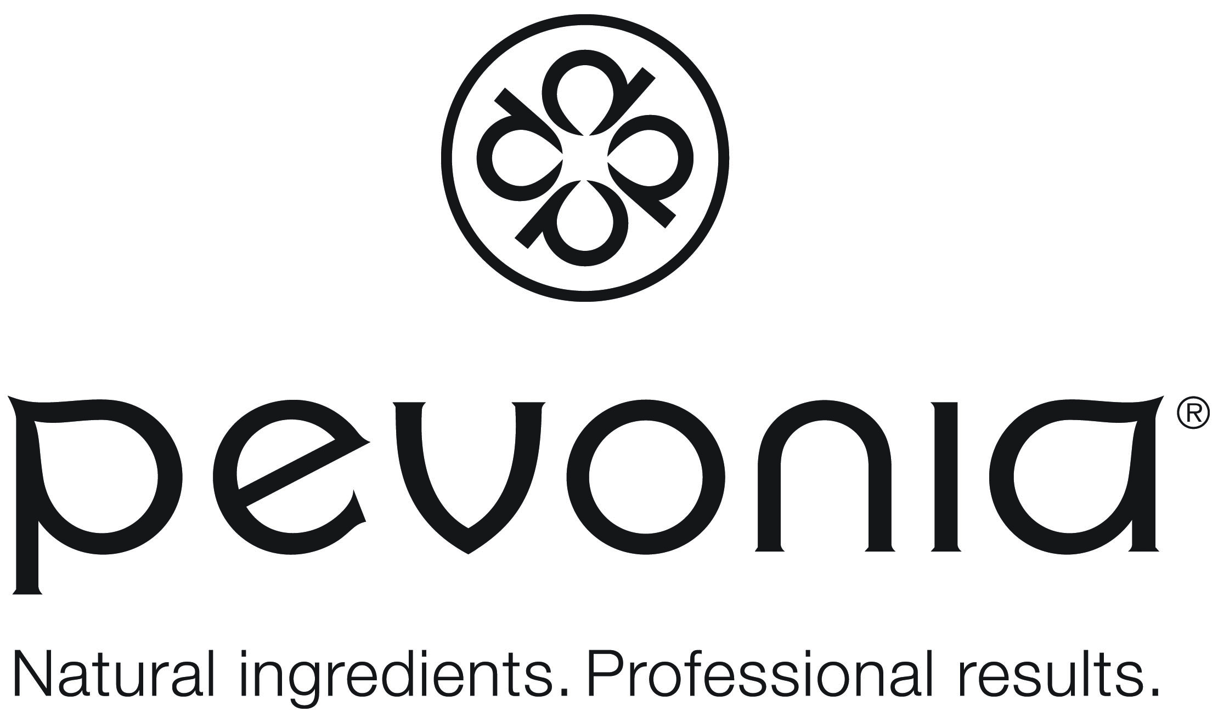 Therapist Name:________________________________________

|  |  |  |  |
| --- | --- | --- | --- |
| **Name of Pevonia Treatment Webinar** | **Date viewed by therapist** | **Quiz Completed**  **Y/N** | **Follow up Required** |
| Essential Lines |  |  |  |
| Module 1 (4 hrs) |  |  |  |
| Mod 2 – Clinical Lines |  |  |  |
| Mod 3 – Advance Ageing |  |  |  |
| Body Module |  |  |  |
| Pevonia Peels At A Glance |  |  |  |
|  |  |  |  |
| Aromatherapy Facial |  |  |  |
| Essential Deep Cleanse |  |  |  |
| Mini/Express Facial |  |  |  |
| Plantomer |  |  |  |
| Anti Free Radical |  |  |  |
| Luminous C and Sea |  |  |  |
| Hydra Cloud |  |  |  |
| Oxy Vital |  |  |  |
| Elasto Firm |  |  |  |
| Skin Fit |  |  |  |
| Myoxy Caviar |  |  |  |
| Lumafirm |  |  |  |
| Micro Retinol |  |  |  |
| Stem Cells |  |  |  |
| RS2 |  |  |  |
| Spa Teen Papaya Hydra Soothe/Blemish |  |  |  |
| Spa Teen Strawberry Hydraboost |  |  |  |
| Youth Renew Hydra Glow Peel |  |  |  |
| Lacto Flora Peel |  |  |  |
| For Men Only Soothing Facial |  |  |  |
| Acne Treatment |  |  |  |
| Ageless Skin Collagen |  |  |  |
| Pure Skin Charcoal |  |  |  |
| Bright Skin Green Apple |  |  |  |
| Escutox Freeze Dried Anti Wrinkle Tube Mask |  |  |  |
| Collagen Cry Eye |  |  |  |
| Ginkgo Biloba Eye |  |  |  |
| Lumafirm Eye |  |  |  |
| Lip Renew Plump and De Age |  |  |  |
| Professional Exfoliants  ClearOZyme/Enzyme |  |  |  |
| Ampoule Upgrades |  |  |  |
| Neck & Decolletage Upgrade |  |  |  |
| **BODY** |  |  |  |
| Body Exfoliants |  |  |  |
| Tropical Yogurt Wraps |  |  |  |
| Aroma Cocoon Wrap |  |  |  |
| Desert Heat Back Wrap |  |  |  |
| No Rinse Crepe No More |  |  |  |
| No Rinse Argave and Cactus Wrap |  |  |  |
| Moor Mud |  |  |  |
| Hydra Sea Wrap |  |  |  |
| Waterlilly Wrap |  |  |  |
| Purifying Back Treatment |  |  |  |
| Lumafrim Body Wrap |  |  |  |
| Green Coffee Wrap |  |  |  |
| Pedicure |  |  |  |
|  |  |  |  |